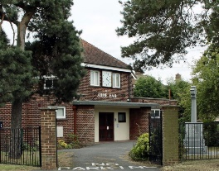
The Keene Hall
(Registered Charity No: 282025)
Booking Enquiry Form
Please complete and send to: administrator@keenehall.com
Your details
Surname: First name: Title:
Address – line 1:
Address – line 2:
Address – line 3:
Postcode:
Phone No: Email address:
Event details
Date(s) required:
Purpose of event (e.g. dance classes; children’s party; club meeting; family celebration):

Numbers attending (approx.):
Start time: HH: MM: Finish time: HH: MM:
Note 1: Allow time at start and end of your event for preparation, clearing up and cleaning
Room(s) required – please tick rooms/facilities required:
Main Hall (seats 150) The Lodge Room (seats 36) Ron White Room (seats 10)
Kitchen (refreshment use only) Kitchen (full cooking facilities)

Note 2: See Hiring Charges April 2018 to March 2019 for prices and minimum charges

Other requirements:
Sound system Microphones Lectern
Use of screen Use of Projector

Enquiries may also be made by phone: 01245 268961, Monday to Friday, from 9.00 am to 1.00 pm

